Experiment No-2
Experiment name: Demonstration of control statements and input Handling.
Task No-1
Task Name: Write a Java program that takes a student's exam marks as input and determines the grade.
Objective:
- To take exam marks as input from the user.
- To determine the grade based on marks.
- To display the grade as output.

Problem Analysis:
In many educational systems, students’ performance is evaluated through marks and then converted into grades. A program can help automate this grading process. The program will accept marks (0–100) and decide the grade using conditional statements. For example:
- Marks ≥ 80 → Grade A+
- Marks 70–79 → Grade A
- Marks 60–69 → Grade B
- Marks 50–59 → Grade C
- Marks 40–49 → Grade D
- Marks < 40 → Fail

Algorithm:
- Start.
- Input student marks.
- Check the range of marks using conditions.
- Assign grade according to the condition.
- Display the grade.
- End.

Source code:
import java.util.Scanner;

public class StudentGrade {
public static void main(String[] args) {
Scanner sc = new Scanner(System.in);

System.out.print("Enter number of marks: ");
int n = sc.nextInt();

int[] marks = new int[n];

System.out.println("Enter marks: ");
for (int i = 0; i < n; i++) {
marks[i] = sc.nextInt();
}

System.out.println("Grades: ");
for (int i = 0; i < n; i++) {
int m = marks[i];
if (m >= 80) {
System.out.print("A+ ");
} else if (m >= 70) {
System.out.print("A ");
} else if (m >= 60) {
System.out.print("B ");
} else if (m >= 50) {
System.out.print("C ");
} else if (m >= 40) {
System.out.print("D ");
} else {
System.out.print("Fail ");
}
}

sc.close();
}
}

Output:
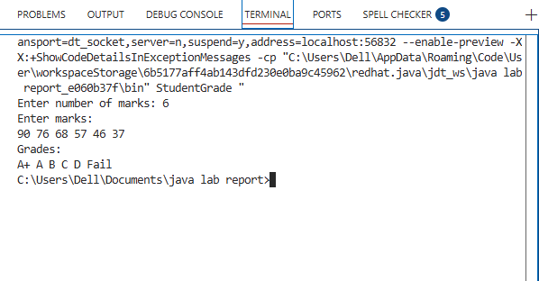
Discussion:
This program is important because it shows how decision-making statements (if–else if–else) are used in Java to classify input into categories. By checking conditions in a specific order, only one grade is assigned for any given mark. The program ensures accuracy and clarity in output, which is essential in real grading systems. It can be easily modified if grading rules change, making it flexible and practical. Overall, this task demonstrates how programming can be used to automate evaluation processes efficiently.

Task No-2
Task 2: Write a Java program that asks the user for two numbers and an operator (+, -, *, /), then performs the selected operation and displays the result.

Objective:
- To input two numbers from the user.
- To input an operator (+, -, *, /).
- To perform the chosen operation.
- To display the result.

Problem Analysis:
A calculator is one of the most common programming tasks. The program should accept two numbers and an operator. Based on the operator, it will perform the corresponding arithmetic operation. Division should also handle division by zero carefully. The result will be shown to the user.

Algorithm:
- Start.
- Input first number.
- Input second number.
- Input operator (+, -, *, /).
- Use switch or if–else to perform the operation.
- Display the result.
- End.

Source Code:
import java.util.Scanner;

public class SimpleCalculator {
public static void main(String[] args) {
Scanner sc = new Scanner(System.in);

System.out.print("Enter first number: ");
double num1 = sc.nextDouble();

System.out.print("Enter second number: ");
double num2 = sc.nextDouble();

System.out.print("Enter operator (+, -, *, /): ");
char op = sc.next().charAt(0);

double result;

switch(op) {
case '+':
result = num1 + num2;
System.out.println("Result = " + result);
break;
case '-':
result = num1 - num2;
System.out.println("Result = " + result);
break;
case '*':
result = num1 * num2;
System.out.println("Result = " + result);
break;
case '/':
if(num2 != 0) {
result = num1 / num2;
System.out.println("Result = " + result);
} else {
System.out.println("Error: Division by zero is not allowed.");
}
break;
default:
System.out.println("Invalid operator!");
}

sc.close();
}
}
Output:
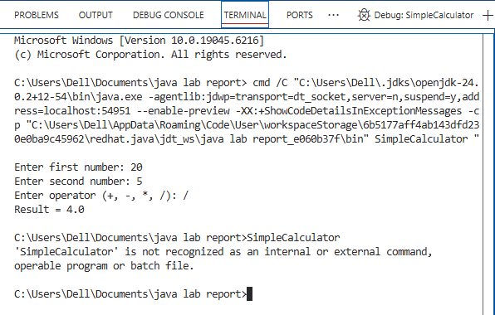

Discussion:
The calculator program demonstrates the use of switch-case branching in Java to perform arithmetic operations based on user input. It accepts two numbers and an operator, then executes the correct operation, which makes it interactive and user-friendly. Special care is taken for division to avoid errors like division by zero, which highlights the importance of error handling in programming. The program can handle both integers and floating-point numbers, making it versatile. It also serves as the foundation for building more advanced calculators or mathematical applications.

